|  |
| --- |
| **HINDUSTHAN INSTITUTE OF TECHNOLOGY**      **Name:** DUNGALA MOHANA PRIYANKA  **Assignment:** Build a python code. Assume u get temperature and humidity values and write a condition to continuously detect alarm in case of high temperature **Date:**28-09-2022  **CODE**:  import random while(True):  temp=random.randint(10,99)  humid=random.randint(10,99)    print("current temperature:",temp)  print("current humidity:",humid,"%")  temp_ref=37  humid_ref=35  if temp>temp_ref and humid<humid_ref:  print("Sound Alarm")  else:  print("Sound off")  break |

**PROGRAME**

**:**

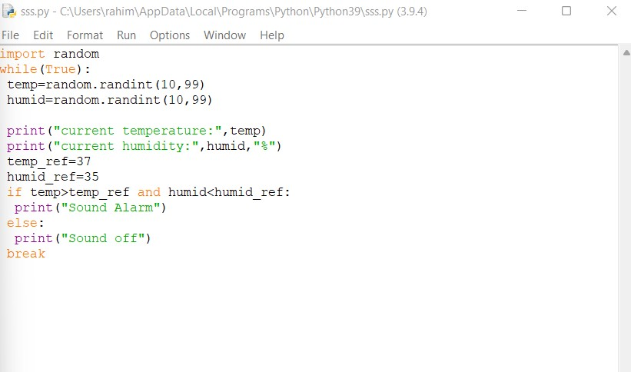

**Output :**

